Energy and Momentum 2A

Name : _____Answers___________

[53 Marks total]

All calculations are to be set out in detail. Marks are awarded for correct equations and clear setting out, even if you cannot complete the calculation.

- A student (50kg) rides her bike(12kg) in a westerly direction at 8.0 m/s. There is a force due to friction and air resistance of 60N.

a) What is the force she must provide?

- If she rides her bike for 1 km west, what work has she done?

(3 marks)

- Whilst on excursion a physics student (62.0 kg) went to Scitech and rode a bike on an exhibit that stated he exerted 1200 Joules in one minute. He knows his bike (15.0 kg) at home provides a force due to friction and air resistance of 50.0N.

- How far over level ground can he go with one minute’s worth of energy?

(2 marks)

b) The student finds that he can not go as far when riding up a hill, why is this?

(2 marks)
3) Explain how having a roo bar fitted to a car can be considered very dangerous to pedestrians or to the car’s occupants in a crash involving something heavier than a kangaroo.

(3 marks)

4) A person on a motorcycle (120 kg) with a 28.0kW motor is at rest.

a) If she accelerates for 5.00 sec from rest, what is her velocity?

(4 marks)

b) How far has the motorcycle gone in this time?

(2 marks)
5) A golfer played a beautiful shot at a weekday golf competition. His golf ball, with a mass of 45.9 grams, was hit with a 0.500 kilogram club travelling at 30.0 ms⁻¹. The ball was given a velocity of 125 ms⁻¹.
Club and golf ball pic
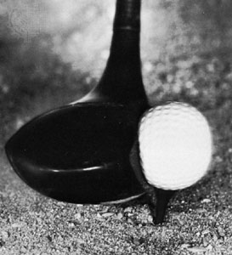
- What is the change in momentum for the ball?

(2 marks)

b) What is the velocity of the club after the collision?

(4 marks)

c) If the collision took place over 2.20 x 10⁻³ of a second what is the average force that was exerted on the ball over this time?

(3 marks)

6) Consider an 80.0 kg carriage on a roller coaster ride as shown in the diagram below:
[15 Marks]
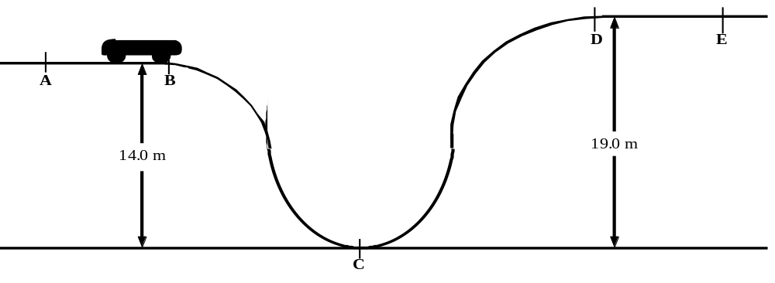

If the initial velocity of the carriage along AB is 12.0 ms⁻¹, calculate the following:

a) The carriage’s kinetic energy along AB.

(2 marks)

b) The potential energy, relative to point C, of the carriage while it is moving along AB.

(2 marks)

c) The total energy the carriage has along AB.

(2 marks)

d) The velocity of the carriage at point C.

(3 marks)

e) The carriage’s kinetic energy at D.

(3 marks)

f) The velocity of the carriage along DE.

(3 marks)

7) A 48.0 kg physics student, after watching the Olympics last year, has decided that he wants to join the Olympic Trampoline Team. He decides to try for the “Highest Jump” event. He manages to drag a 1.00 m tall trampoline to the base of a 9.00 m high cliff. He climbs to the top, closes his eyes and imagines the Gold Medal around his neck.
[13 Marks]
- Using the trampoline as a reference point. What is the potential energy he possesses?

(3 marks)

b) He leaps off the cliff in perfect form, hitting the centre of the trampoline. What is his velocity at this point?

(3 marks)

c) The trampoline exerts a constant resistive force of 7400N. How far does the trampoline stretch downwards before he is catapulted up into the air?

(4 marks)

d) The trampoline absorbs some of the energy in accelerating him up, if the trampoline absorbs 25.0% of the energy in changing his direction, how high will he go?

(3 marks)

